Non-coding RNA in MND/ALS Meeting at ENCALS 2022
Friday 3rd June 2022
McEwan Hall, Edinburgh, Scotland
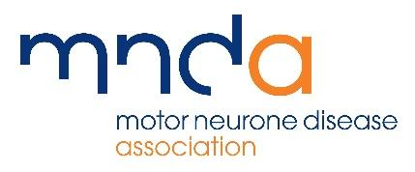

Supported by

The aim of this mini-symposium is to share the latest expertise and knowledge in the field of ALS biomarkers. We will pay special attention to microRNAs and other non-coding RNAs, and the current efforts in using machine learning approaches to identify an ALS biomarker signature for use in clinic.

Time | Speaker
13:30 - 13:35 | Opening Remarks
13:35 - 14:05 | Dennis Wang - University of Sheffield, UK  ‘Diagnosis and patient stratification using machine learning of miRNA profiles’
14:05 - 14:35 | Axel Freischmidt - University of Ulm, Germany  ‘Healthy aging of serum/plasma microRNA pofiles is impaired in ALS’
14:35 - 15:05 | Greig Joilin - University of Sussex, UK  ‘Identification of ncRNA biomarkers in longitudinal serum samples from people with ALS’
15:05 - 15:35 | Gunter Meister - Universität Regensburg, Germany  ‘Regulation of miRNA-guided gene silencing and its link to neurological and developmental disorders’
15:35 - 16:00 | Break  Tea, coffee, and cake
16:00 - 16:30 | Nancy Yacovzada - Weizmann Institute of Science, Israel  Machine Learning approach for microRNA Biomarkers in Neurodegeneration.
16:30 - 17:00 | Alberto Tonda - French National Institute for Agriculture, Food, & Environment, France  ‘miRNA signature for cancer classification using ensemble feature selection’
17:00 - 17:25 | Group Discussion  Outstanding questions and opportunities in research for non-coding RNA in MND
17:25 - 17:30 | Closing Remarks

Organising Committee:
Majid Hafezparast, University of Sussex, UK
Ana Cristina Calvo Royo, IHRA (IIS Aragon), CIBERNED, University of Zaragoza, Spain
Greig Joilin, University of Sussex, UK
Janine Kirby, University of Sheffield, UK
Jochen Weishaupt, University of Heidelberg, Germany

